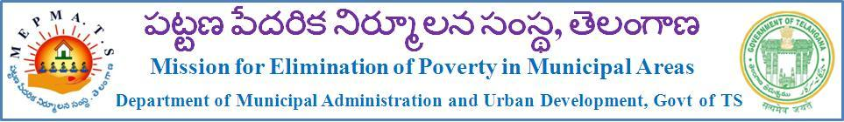
From To,
Smt K. Nirmala I.A.S, All the Municipal Commissioners
Mission Director (HFA) & Project Director of MEPMA, MEPMA, Telangana
Telangana, State
Hyderabad

Lr. No. 602/C2/HFA/T.S, Dated: 18 .09.2015.
Sir,
Sub: - MEPMA (T.S) – Housing for All (Urban) Mission – Workshop on housing for all (Urban) Mission on 22.09.2015 at 11.00 AM, in the Conference Hall of CDMA, Telangana, Hyderabad – Reg.
-::-::-::-
You are all aware that the GoI has recently launched the Housing for All (Urban) Mission to address the Housing requirement of the urban poor. In pursuance of the implementation of the Housing for all (Urban) Mission, it is desired to conduct a workshop on 22.09.2015 at 11.00 AM in conference CDMA Telangana.
Hence all the Municipal commissioners and Project Directors of MEPMA, Telangana State are here by requested to attend the above workshop along with the Municipal Engineers and Town planning officers.

Sd/-
MISSION DIRECTOR

Copy to the Commissioner & Director of Municipal Administration of Telangana State.

ANNEXURE 1
LIST OF HOUSING FOR ALL TOWNS
1.Hyderabad | 20. Miryalguda
2.Warangal | 21. Bhongir
3. Mahabubabad | 22. Mahaboobnagar
4. Jangaon | 23. Achampet
5. Karimnagar | 24. Nagarkurnool
6. Huzurabad | 25. Kollapur
7. Jammikunta | 26. Wanaparthy
8. Metpalli | 27. Shadnagar
9. Husnabad | 28. Sangareddy
10. Sircilla | 29. Medak
11. Nizamabad | 30. Dubbaka
12. Armoor | 31. Gajwel
13. Bodhan | 32. Siddipet
14. Khammam | 33. Zaheerabad
15. Palvancha | 34. Vikarabad
16. Adilabad | 35. Ramagundam
17. Nirmal | 36. Mancherial
18. Nalgonda | 37. Bhainsa
19. Suryapet

Note: Workshop on Housing for all urban 22-09-2015 at 11. AM of CDMA
Conference Hall.

